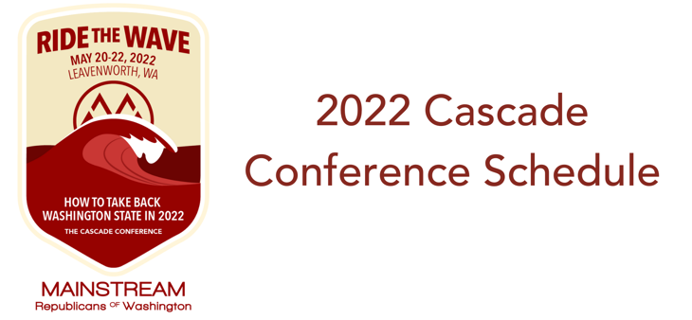

Friday, May 20th

4:00 – 6:00 PM – Registration (Upper Lobby)

6:00 PM – Welcome Reception (Alpine Room) - Sponsored by Jesse Jensen for Congress

7:00 PM – Conference Kick-Off, Words from MRW Board Chair Jon Nehring, Introduction of Candidates (Alpine Room)

8:00 PM - 8th Congressional District Candidate Discussion (Alpine Room)
- Reagan Dunn, Jesse Jensen, Matt Larkin

9:00 PM – Hospitality Suite (The Hutte) – Sponsored by Nate Nehring and Benji Backer

Saturday, May 21st

Breakfast provided to hotel guests

8:15 AM - “The Hunt for Red November” Polling Presentation – Stuart Elway (Alpine Room)

9:00 AM – Panel – Leading the Way with the Next Generation of the GOP (Alpine Room)
- Simon Sefzik, Skyler Rude, Caitlin O’Dell, Moderator - Marissa Gaston

9:55 AM – Break

10:00 AM – Panel – Bringing Balance to the News Media (Alpine Room)
- Jason Rantz, Paul Queary, Jerry Cornfield, Moderator - Brandi Kruse

10:55 AM – Break

11:10 AM – Panel – Diversity and Inclusion: The Right Way (Alpine Room)
- Kaitlin Vintertun, Kamal Bhachu, Susanna Keilman, Moderator – Deanna Martinez

12:00 PM – Lunch & Virtual Speaker – Steve Hayes (Alpine Room)

1:30 PM – Breakout Panels –
- Environment and Conservation: Yes, Republicans Care
  - Benji Backer, Todd Myers, Mary Dye, Moderator - Alex Ybarra
- Transparency in Education: How Involved Should Parents Be?
  - Brad Hawkins, Mike Steele, Moderator – Maia Espinoza

2:25 PM – Break

2:30 PM – Panel – Restoring Public Safety and Security in the Evergreen State (Alpine Room)
- Ann Davison, Jim Ferrell, Adam Fortney, Moderator - Jon Nehring

3:30 PM – Afternoon Break

5:30 PM – Reception (Continental Room) – Hosted by Opportunity for Washington

6:30 PM – Dinner Service, Awards, Auction (Continental Room)

8:30 PM – Keynote Speaker - Brandi Kruse (Continental Room)

9:30 – 11:00 PM – Hospitality Suite (The Hutte) – Sponsored by Reagan Dunn

Sunday, May 22nd

Breakfast provided to hotel guests. Hotel checkout is at 11:00 am

9:00 AM – Panel – Ride the Wave into the 2022 Legislative Races and Redistricting (Alpine Room)

10:15 AM – Mainstream Business Board and Membership Meeting (Alpine Room)

12:00 PM – Conference ends

